Brieanna Williams Assignment 9.2
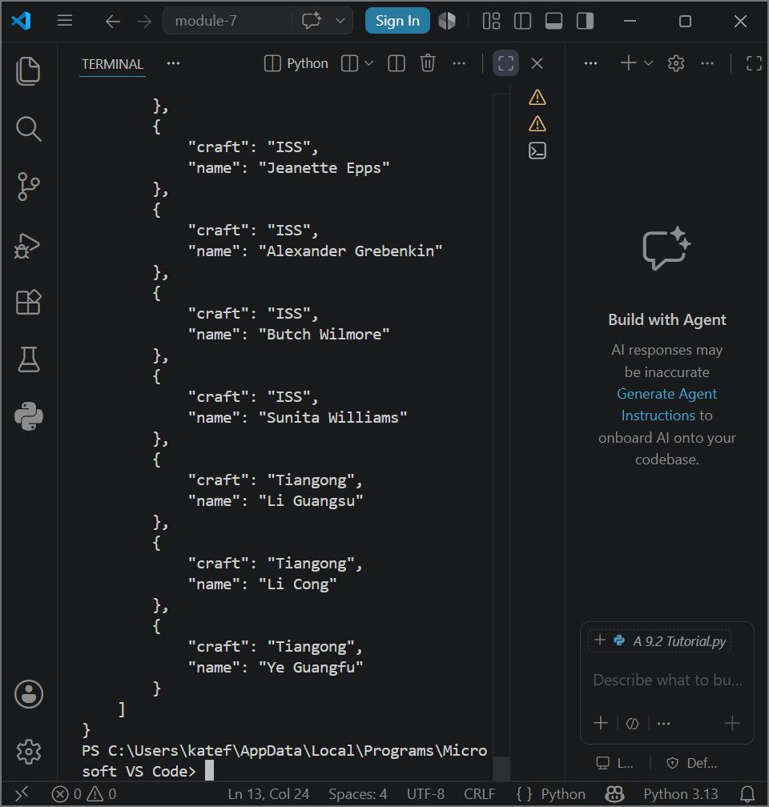
Tutorial
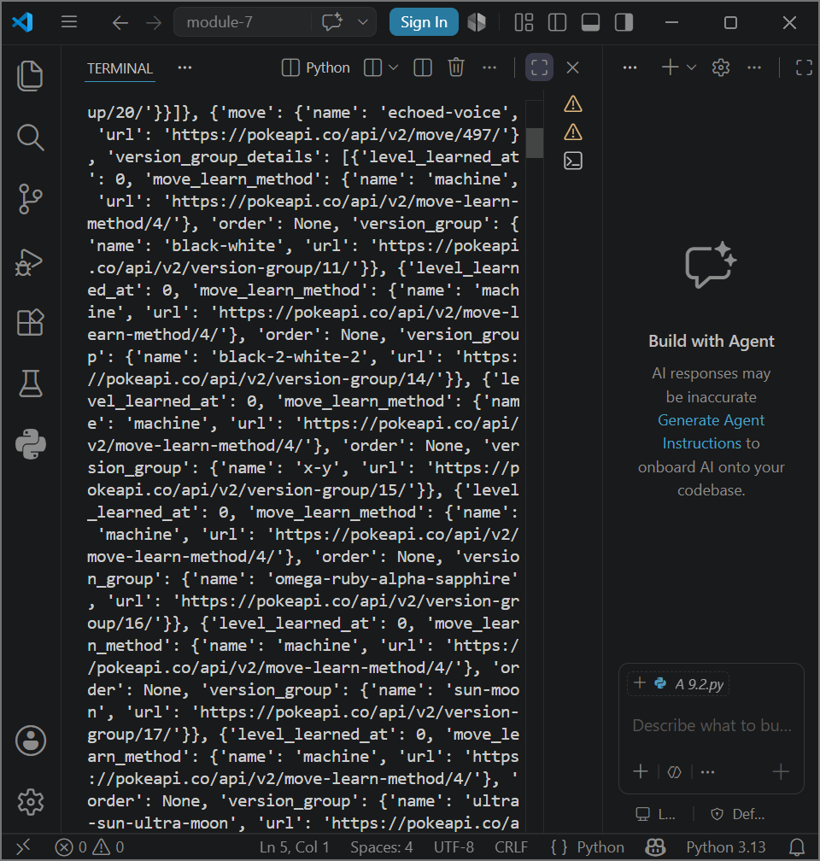
Pokeapi pre-formatting
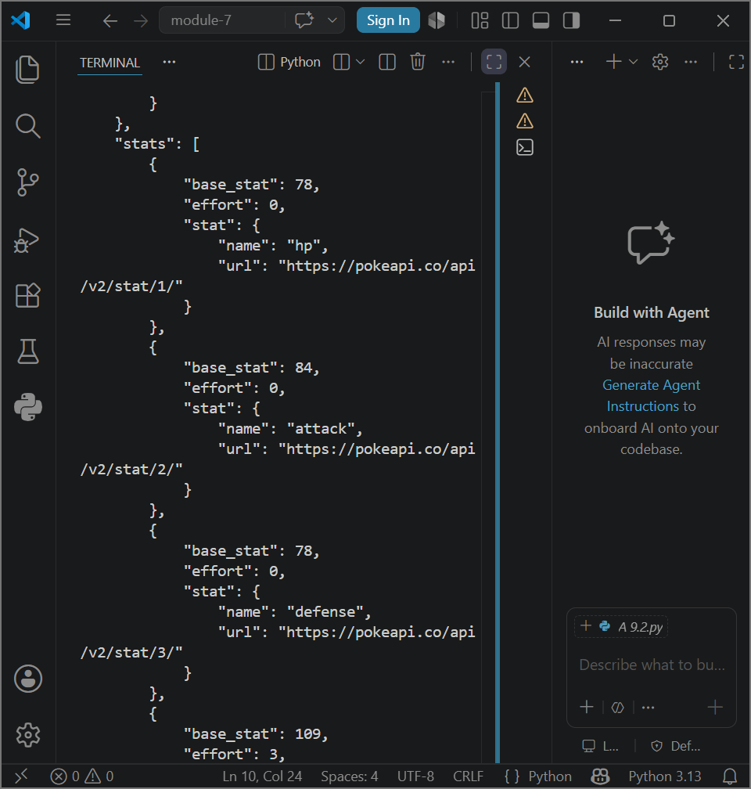
Pokeapi post-formatting

